CASE STUDY 14 Warehouse Inventory Reconciliation
- Problem Statement
Compare opening stock, incoming stock, dispatched stock, and recorded closing stock for several products, and report discrepancies and replenishment needs.
2. Objectives
Use lists and loops to process multiple products.
Calculate expected closing stock.
Compare expected and recorded values.
3. Assumptions
Expected closing stock = opening + received − dispatched.
All quantities must be non-negative.
Target stock levels are supplied for each product.
4. Algorithm
1. Read the number of products.
2. For each product, read name, opening, received, dispatched, recorded closing, and target stock.
3. Validate non-negative quantities and that dispatched stock does not exceed available stock.
4. Calculate expected closing stock and discrepancy.
5. Calculate replenishment required to reach target stock.
6. Print a report for every product.
5. Flowchart
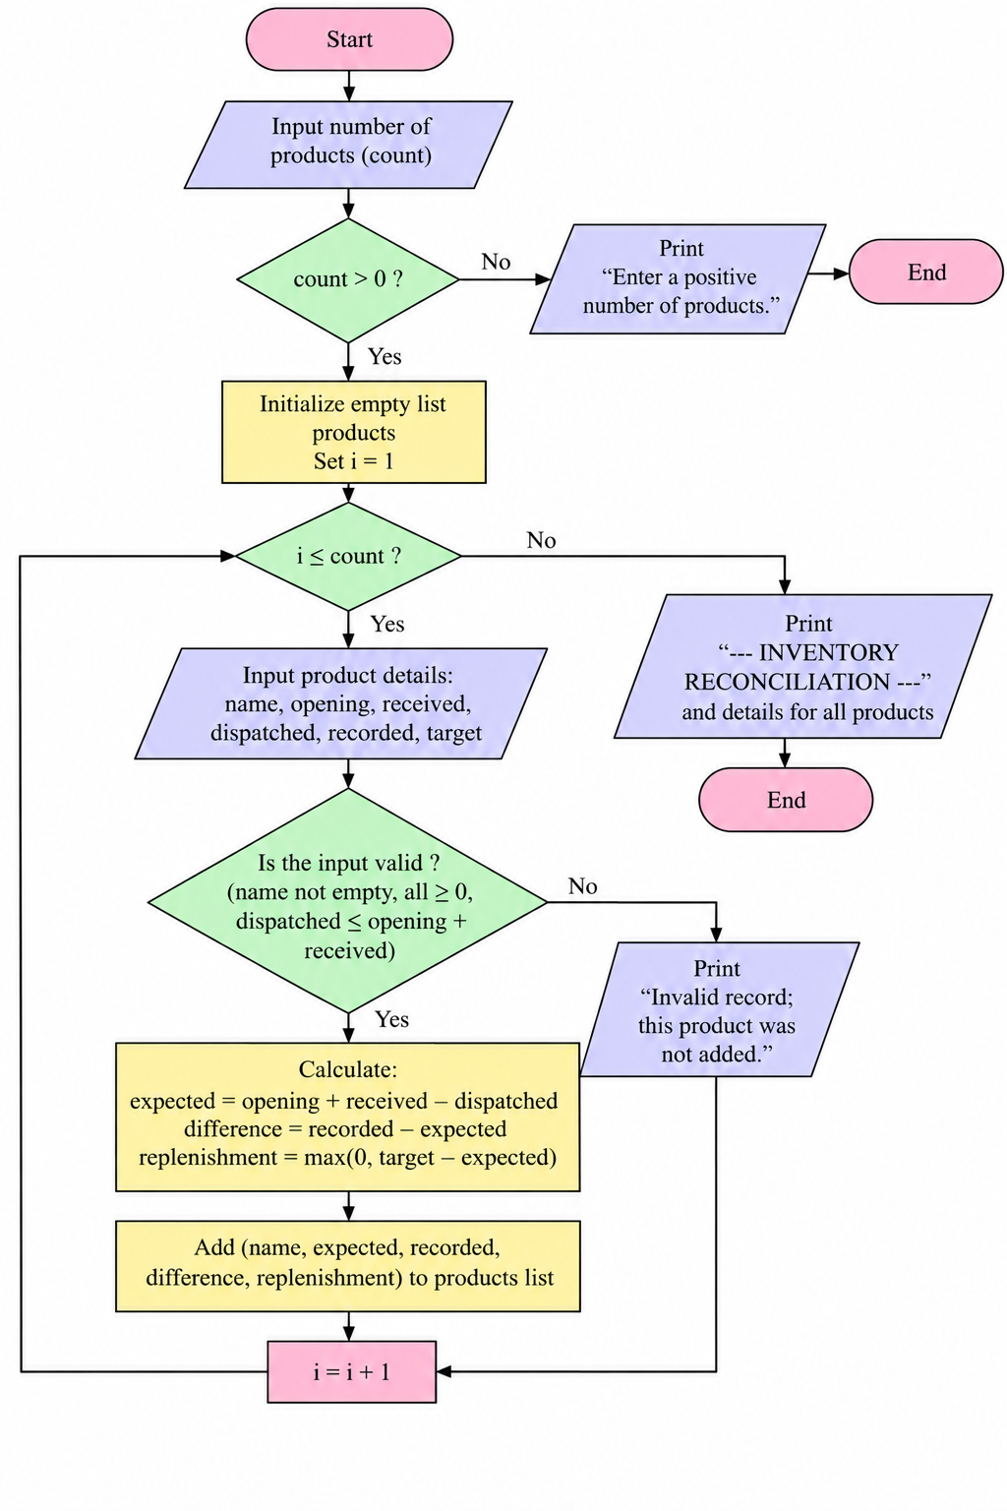
6. Pseudocode
START
INPUT number of products
FOR each product: INPUT quantities and target
IF any quantity is negative OR dispatched > opening+received: report invalid record
ELSE expected = opening + received - dispatched
difference = recorded_closing - expected
replenishment = max(0, target - expected)
PRINT product report
END FOR
7. Test Cases
Test | Input / Scenario | Expected result
1 | Pen: opening 100, received 20, dispatched 30, recorded 90, target 120 | Expected 90; difference 0; MATCH; replenish 30
2 | Book: opening 50, received 0, dispatched 10, recorded 45, target 60 | Expected 40; difference 5; DISCREPANCY; replenish 20
3 | dispatched > opening+received | Invalid record

8. Output Screenshot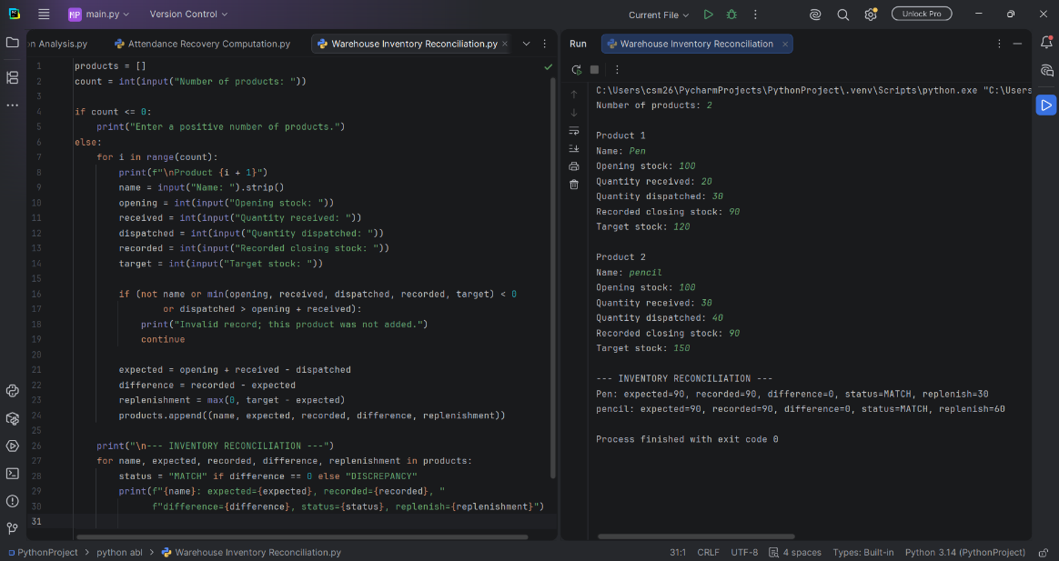
9. Conclusion
The program reconciles stock records, flags mismatches, and calculates the quantity needed to reach a target stock level.

